**Using the Command Prompt**

**Time Required:** Approximately 15 minutes

**Objective:** Learn how to access the command prompt from the Windows Server 2016 installation DVD.

**Description:** If you have an area of disk damage or a corrupted system file and cannot boot a server, using the installation DVD to access the command prompt can be critical. In this mode you can attempt to replace a system file, fix the boot problem, or copy important files off of the server. In this activity, you use the Windows Server 2016 installation DVD to access the command line.

1. Ensure that the **Choose an option** screen is displayed. If it is not and you have to go back into the repair mode.
2. Click **Troubleshoot** in the Choose an option screen.

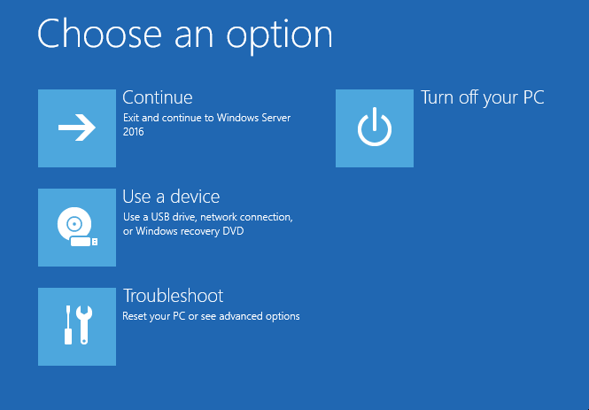

1. Click **Command Prompt** in the Advanced options screen.

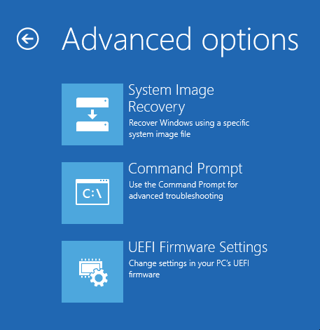

1. You'll see a command prompt window (you’ll see a screen that has black background and white text).

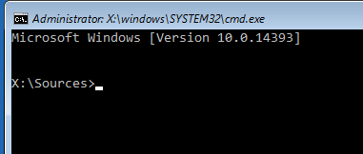

1. Type **dir \Windows** and press **Enter** to view the files and subdirectories in the \Windows directory (containing system files).
2. Type **copy /?** and press **Enter** to view the documentation for the copy command. Press the **spacebar**, if necessary, to display the remaining documentation.
3. Type **chkdsk** to check the file system and press **Enter**.

When chkdsk is finished, you are likely to see the message “Failed to transfer logged messages to the event log with status 50." because chkdsk cannot write to the event log in this mode. Also, if errors are found, you'll see a message that you can use chkdsk /f to fix file system errors.

1. Type **exit** and press **Enter** to close the Command Prompt window.
2. On the Choose an option screen click **Turn off your PC**.



1. Boot up your system and sign back in.